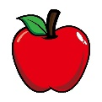**Matematika i jabuke**

1. **Izračunaj s pomoću jabuka.**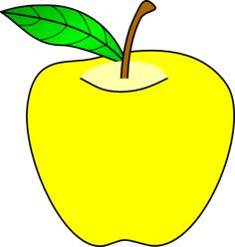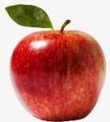

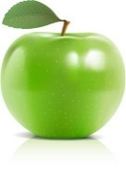

**stotice**  **desetice** **jedinice**

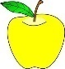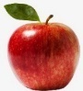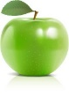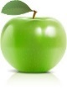

341 + 132 = ________

425 + 204 = ________

536 + 43 = ________

714 + 45 = ______

126 + 302 + 41 = _______

22 + 305 + 231 = ________

1. **Riješi sudoku.**

|  |  |  |  |
| --- | --- | --- | --- |
|  |  | This may contain: an apple with two green leaves on the top and one red in the bottom half | https://i.pinimg.com/564x/4f/6c/c4/4f6cc46e50e7a0ff21c5e0a77423b0b5.jpg |
| This may contain: an apple with two green leaves on the top and one red in the bottom half |  |  |  |
| Yellow Apple clip art | Shiny green apple vector material - Vector Food free download |  |  |
|  |  |  | Shiny green apple vector material - Vector Food free download |

1. **Pomozi crvu pronaći put do jabuke.**

